Ansible
ansible is a tool that helps automate repetitive computer tasks so people don't have to do them manually. Think of it like giving instructions to computers on a network to set up software, update systems, or manage configurations — all done automatically. It uses simple, easy-to-read instructions called playbooks written in a basic language called YAML. You only need one main computer to send these instructions, and the computers being managed don’t need any extra software installed.
For example :
We have 100 of server and that need maintain such as upgrading, security patch, and installing software as per developer requirements. These are task and it extremely difficult to login each and every server and do configuration.
What people used to do before ansible
They used to write a shell script for Linux server, if it is windows they will write power shell. Command will change for server, some server are having centos OS , Ubuntu and windows. it is very difficult to manage server.
It doesn’t need any special software on the computers it controls, and it uses secure connections to talk to them. This saves time, reduces mistakes, and makes managing lots of computers easier, even if you’re not a programming expert.
Ansible is constantly developed by RED hat
That's why configuration management invented. There are popular tools such as puppet, ansible, salt.
Why ansible is so popular?
-- It is an agent less model. means we can easy connect any server and do the configuration with ip ad password authentication should be enabled.
-- Ansible can be used to scale up and scale down infrastructure resources, particularly in cloud environments like AWS
-- it is pretty compatible for both linux and windows.
--- ansible is very simple .it is a simple yaml file ;it is using global language so devlopers will understand it.
-- we write our own ansible modules
Drawbacks of Ansible

-- People facing while using the ansible for window os
-- There is a issue while debugging
-- There is some issue in performance
To establish password less SSH authentication between two Linux servers using SSH key-based authentication, follow these steps:
STEPS:
- Generate SSH key pair on the source server:
To generate an SSH key pair on the source server (where Ansible is installed), run the following command in the terminal:

COMMAND - “ ssh-keygen “

- Copy the public key to the target server:
Go inside .ssh folder and copy the Public key of source server or computer and past it inside the target server folder (authorized_keys) .
cd /home/ubuntu/.ssh/ --- ( authorized_keys id_ed25519 id_ed25519.pub)

cat id_ed25519.pub (public key)
ssh-ed25519 AAAAC3NzaC1lZDI1NTE5AAAAICe6pQhB5FZKf3zpxKqGRPqc0VlRQ+Cr/VYYvJWoE/pg ubuntu@ip-10-0-22-49

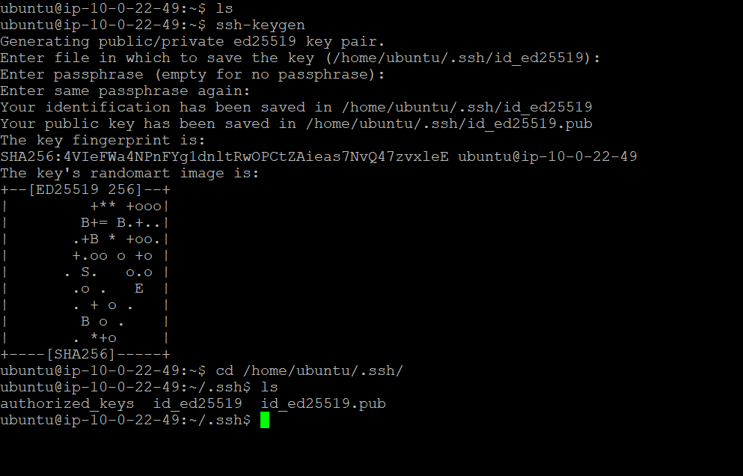
- RUN the command
Once public key configuration is done. Taking the private ip of the target server .try to connect it from source computer (ansible installed).

COMMAND: ssh 17.16.11.11 <ip private address of the target server>

Ansible inventory file
The inventory file defines the machines or devices known as "hosts" that Ansible can connect to and automate tasks on.
It is contain ip address of target server.
Hosts can be grouped together (e.g., webservers, database servers), making it easier to run commands on multiple related systems at once.
Ansible inventory consists of several key components as follows,
- Hosts: These are individual machines or devices managed by Ansible.
Hosts are the individual machines or devices that the control node manages and automates tasks on. These hosts can be physical servers, virtual machines, network devices, or any executable node that Ansible can connect to. Hosts are listed in the inventory file either by their IP addresses or fully qualified domain names (FQDN).

Example for both hosts and groups:--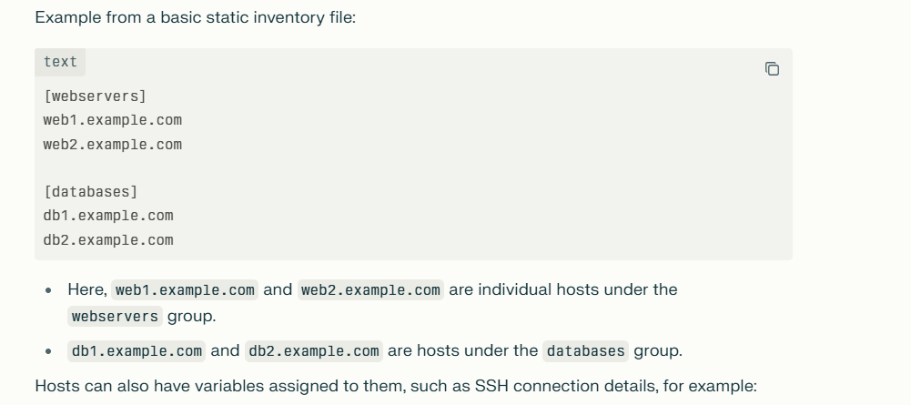

- Groups: Logical collections of hosts. Groups can help organize hosts by roles, environment, or other criteria.

A) Groups are defined by a name enclosed in brackets, e.g., [webservers].
B) Hosts can belong to multiple groups simultaneously.
C) Groups can contain other groups (nested/groups of groups).
D) Ansible automatically creates two default groups: all (contains every host) and ungrouped (hosts not assigned to any group).
C) Variables can be assigned to groups to apply configurations collectively.

Example:
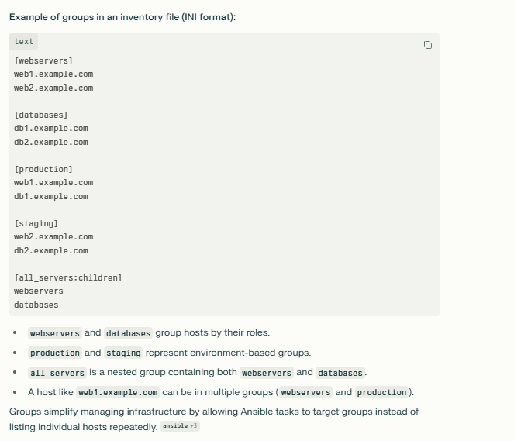

- Variables : Key-value pairs that define configuration specific to hosts or groups.
Variables are like labels or instructions you attach to hosts or groups to tell Ansible specific details—such as usernames, ports, or software versions—so it knows exactly how to manage each machine.
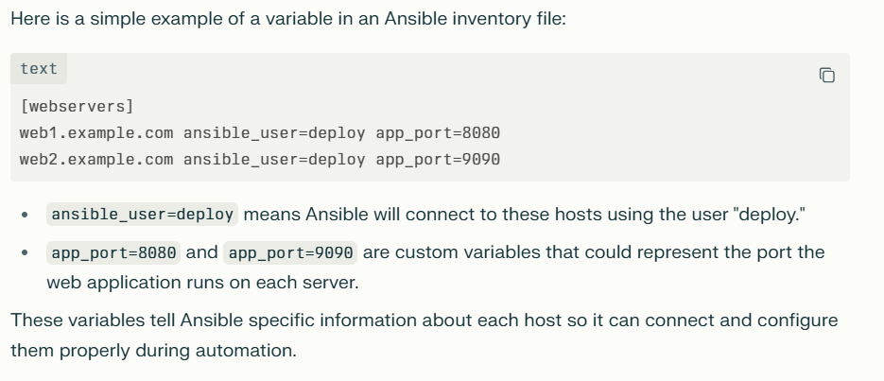
- Inventory Sources:

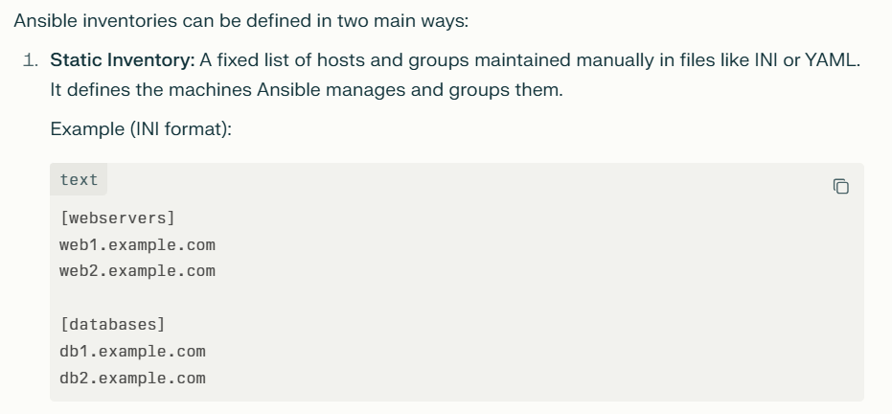

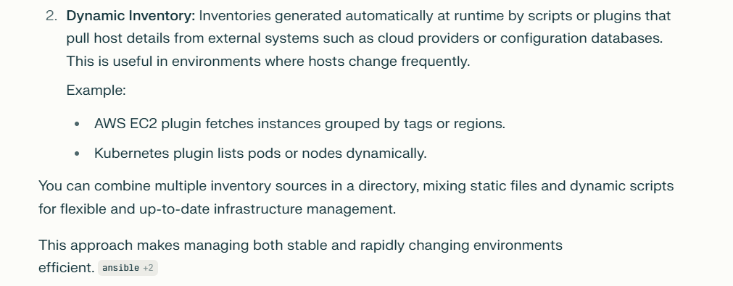
N
Anisble adhoc command
Ansible ad-hoc commands are quick, one-line commands used to perform simple tasks on one or more managed hosts without writing a full playbook.
If we to preform single task we go for Anisble adhoc command . it is like linux shell command(ls ,pwd)
Common Examples:
1) Check connectivity to all hosts:
ansible all -m ping

2) Run a shell command on all hosts:
ansible all -a "/bin/echo hello"

3) Copy a file to all hosts:
ansible all -m copy -a "src=/local/path/file dest=/remote/path/file"
4) Restart a service on a group called webservers:
ansible webservers -m service -a "name=httpd state=restarted"
ansible -i inventory all -m reboot –b

5) Reboot all hosts in a group called servers:
ansible servers -a "/sbin/reboot"
6) Common Cache Clearing Commands:
a) For Linux system cache (page cache, dentries, and inodes):
sudo sync; sudo echo 3 > /proc/sys/vm/drop_caches
b) Clear yum cache
sudo yum clean all
c) Clear apt cache:
sudo apt-get clean
--------------------------------------------------------------------------------------------------------------------------------------
What is the difference between Anisble adhoc command and playbooks

Ad-hoc Commands:
One-line commands executed directly via the ansible CLI.
Used for quick, one-time, simple tasks or checks (e.g., restarting a service, checking uptime).
Do not require writing YAML or saving a file.

Playbooks
Written as YAML files defining one or more plays (sets of tasks).
Suitable for complex automation involving multiple tasks, dependencies, and ordered execution.
Support loops, variables, conditionals, handlers, roles, and reusable automation workflows.
Used for configuration management, deployments, and orchestrating multi-step processes.

-------------------------------------------------------------------------------------------------------------
Ansible –i inventory 172.16.11.11
Or
Ansible –i inventory all

Instead of specify the ip address we use “ all “ .so what and all ip addresses are mentioned in Inventory file will be accessed

Ansible –i inventory all –m “shell” –a “touch devopsclass”
-i inventory specifies the inventory file or directory named "inventory" which contains the list of hosts.
all means target all hosts in the inventory.
-m shell uses the shell module to run a shell command.
-a "touch devops class" passes the argument which is the shell command touch devops class. It is create the devopsclass file in target server.

Yellow color means it is working or correct

if to preform single task we go for

Note:

We have to keep the inventory file inside the
/home/ubuntu/.ssh/inventory

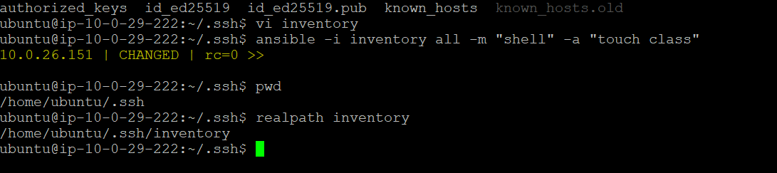

Using inventory file we can run webserver and DB server separately

- If we run the command -- ansible –i inventory webserver^Cm “shell” –a “df
Only webserver will run

We can make a group in the inventory file run specific package or command on particular server
For example : we want run some command only for web server
--ansible –i inventory webserver^Cm “shell” –a “df –

--------------------------------------------------------------------------------------------------------------------------------------

Ansible modules:-

Ansible modules are small programs that do specific jobs on computers you manage. They can install software, create files, manage users, or start services. You use modules in your playbooks or commands to automate tasks easily without writing complex code.
Example:
- apt module - installs a package on Debian/Ubuntu:
- - name: Install nginx
ansible.builtin.apt:
name: nginx
tate: present

2) yum module - installs a package on RHEL/CentOS:
- name: Install nginx
ansible.builtin.yum:
name: nginx
state: present
- service module - restarts a service:

- name: Restart docker service
ansible.builtin.service:
name: docker
state: restarted

- file module - creates a directory with permissions:

- name: Create directory /etc/test
ansible.builtin.file:
path: /etc/test
state: directory
mode: '0750'

- copy module - copies a file with ownership and permissions

- name: Copy file to remote machine
ansible.builtin.copy:
src: /local/path/test
dest: /remote/path/test
owner: user
group: users
mode: '0644'

-------------------------------------------------------------------------------------------------------------------------------------
NOTE:
Before running ansible command we have to establish the password less authentication between servers and specify the target server ip address in the inventory file

Ansible Playbook
An Ansible Playbook is like a list of instructions written in a simple, easy-to-read language called YAML.
It tells Ansible what tasks to do on which computers. Instead of doing things manually on each computer, you write these instructions once, and Ansible repeats them automatically for you.
For example, a playbook can tell Ansible to install a program, copy files, or start services on a group of servers. It helps you automate boring, repetitive work safely and quickly.

For example:
Ansible playbook for installing and starting the Nginx web server on all managed servers.
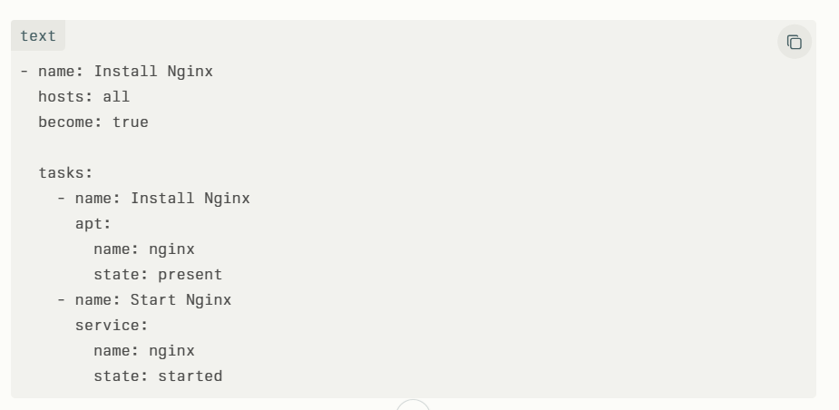
The playbook runs on all hosts (hosts: all).
It uses become: true to run commands with root privileges.
The first task installs the Nginx package using the apt module.
The second task starts the Nginx service using the service module.
This playbook ensures Nginx is installed and running on all targeted servers.
To run this playbook, save it as a .yml file (e.g., install_nginx.yml) and execute:
ansible-playbook install_nginx.yml
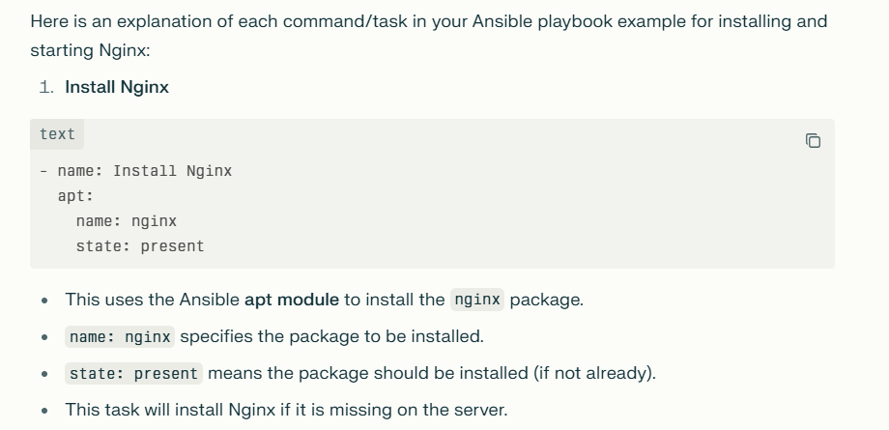

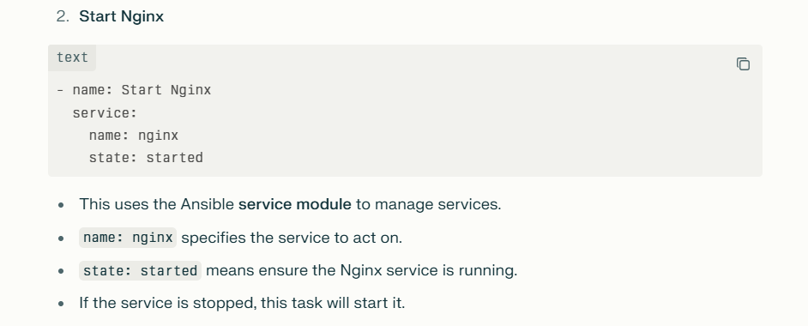

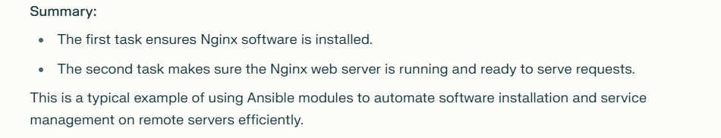

Example 2 : Restart the Nginx service
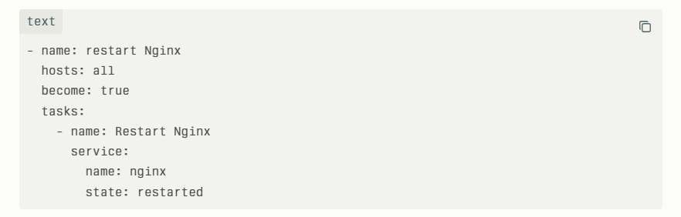

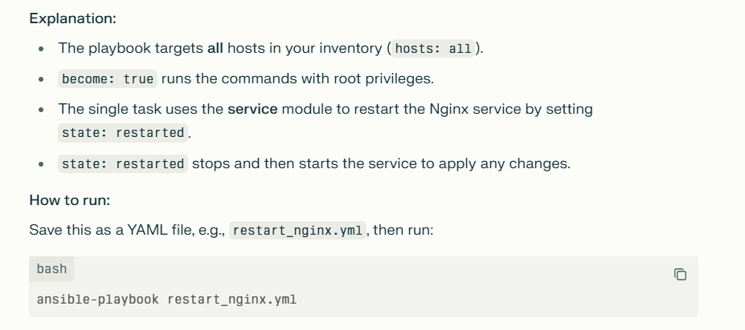
ansible-playbook restart_nginx.yml

Example: 3- Installing Docker for Target server

- name: Install Docker
hosts: all
become: true
tasks:
- name: Update apt and install prerequisites
apt:
name:
- apt-transport-https
- ca-certificates
- curl
- software-properties-common
state: present
update_cache: yes

- name: Add Docker’s official GPG key
apt_key:
url: https://download.docker.com/linux/ubuntu/gpg
state: present

- name: Add Docker APT repository
apt_repository:
repo: deb [arch=amd64] https://download.docker.com/linux/ubuntu focal stable
state: present

- name: Install Docker Engine
apt:
name:
- docker-ce
- docker-ce-cli
- containerd.io
state: present
update_cache: yes

- name: Ensure Docker service is started and enabled
systemd:
name: docker
enabled: yes
state: started

Example 4: Command to restart the docker

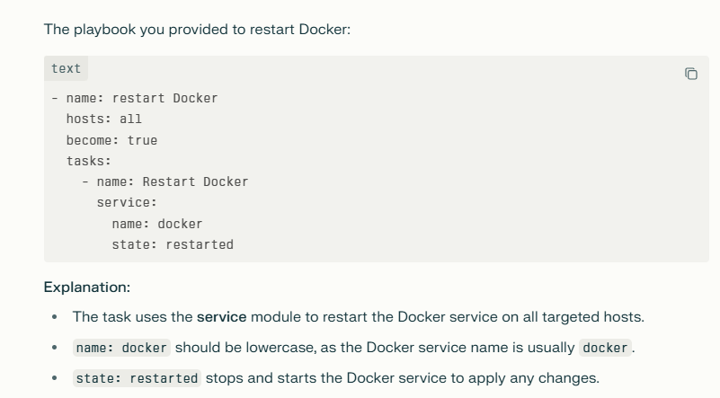

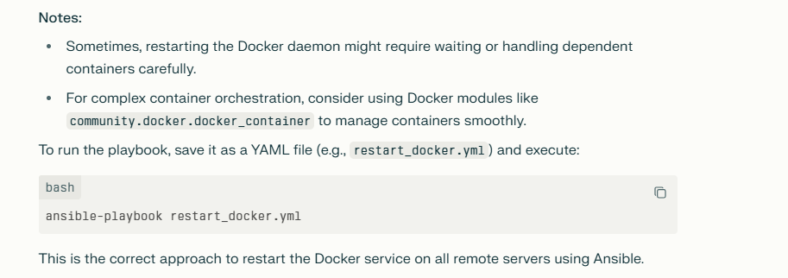

1)Explain the architecture of Ansible.
Ansible follows a client-server model with a control node and managed nodes, communicating over SSH without agents.
2) What are modules in Ansible?
Modules are reusable units of code that perform specific tasks, like installing packages or managing services.

Realtime example:

In server 10.0.30.232, Apache2 serivce is not running

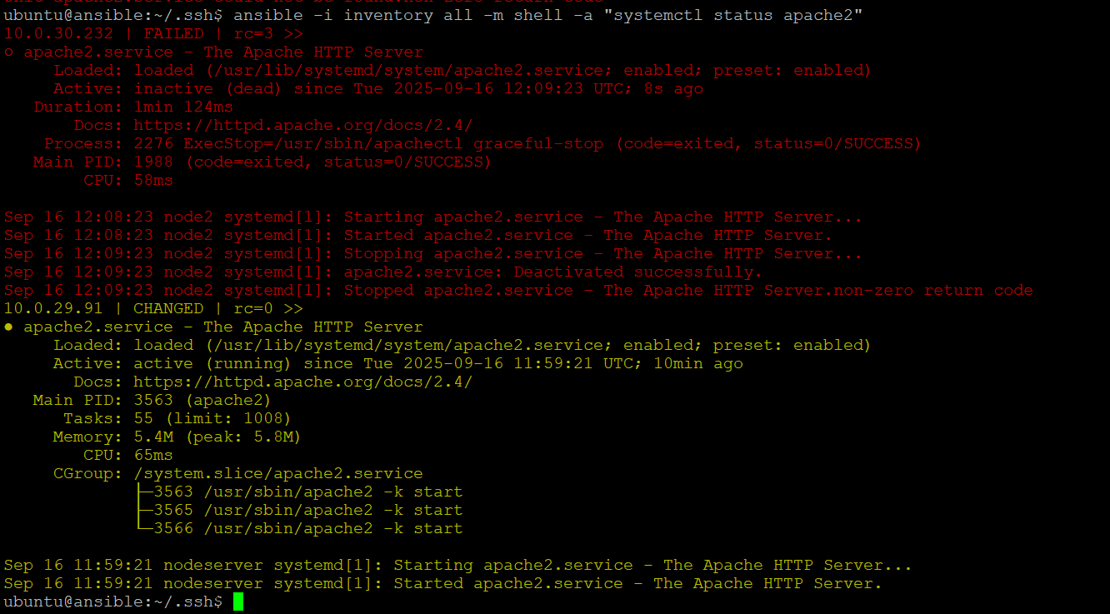

Command to restart apache2 service


Output:

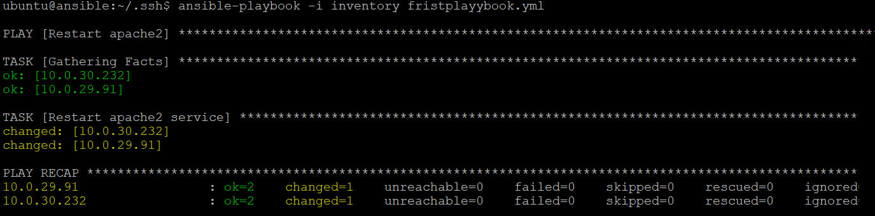

Example : restarting Docker in all service
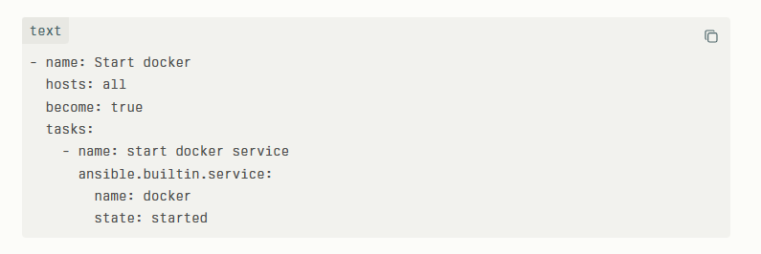

Output:
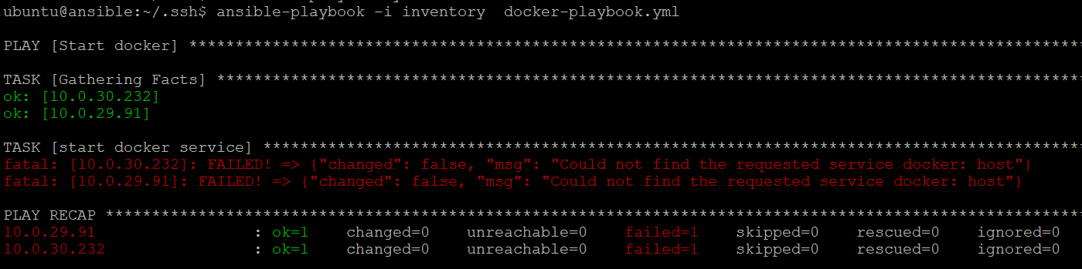

NOTE: It’s showing error because in one server we didn’t installed Docker.

